**Software Architecture Document**

Version 1.20

for

***Second Soul***

Prepared by Team Second Soul

|  |  |  |
| --- | --- | --- |
| Marouen Lamiri | 6226744 | [marouen.lamiri@gmail.com](mailto:marouen.lamiri@gmail.com) |
| Emmanuel Tsapekis | 5849004 | [e.tsapekis@gmail.com](mailto:e.tsapekis@gmail.com) |
| Guillaume Fortin | 6431526 | [xguillaumex@hotmail.com](mailto:xguillaumex@hotmail.com) |
| Nicolas Chausseau | 6325300 | [nicolas.chausseau@gmail.com](mailto:nicolas.chausseau@gmail.com) |
| Dan Magiaru | 9217479 | [dan.magariu@gmail.com](mailto:dan.magariu@gmail.com) |

|  |  |
| --- | --- |
| Instructor: | Dr. Rigby, Peter |
| Course: | SOEN 490 |
| Date: | 11/01/2014 |

**Document history**

|  |  |  |  |
| --- | --- | --- | --- |
| **Date** | **Version** | **Description** | **Author** |
| 06/13/2014 | 0.10 | Added Section 1, 2, 3 and 4 | Marouen Lamiri |
| 09/24/2014 | 1.00 | Updated Section 1, 2, 3 and 4 | Marouen Lamiri |
| 10/15/2014 | 1.10 | Updated Architectural Representation | Marouen Lamiri |
| 01/11/2014 | 1.20 | Updated Architectural Representation | Marouen Lamiri |

Table of contents

1. Introduction 4

Purpose 4

Scope 4

Definitions, acronyms, and abbreviation 4

2. Architectural representation: Package Diagram 5

*Figure 1: Package Diagram - Overview* 5

*Figure 2: Package Diagram - Character* 6

*Figure 2: Package Diagram - Skills* 6

*Figure 4: Package Diagram – HUD/Menu* 7

3. Architectural requirements: goals and constraints 7

Functional Requirements 7

Non-Functional Requirements 9

4. Scenarios 10

Use case 10

Use case diagram 22

*Figure 5: Use Case Diagram* 23

# Introduction

Second Soul is a video game set in a Fantasy world with demons and monsters. The gameplay consist of playing with another person to defeat the monsters and take treasures, among other things. It also enables multiplayer with several other teams of people. The teams can help each other in quests or simply compete with each other. There is also a storyline which will not be presented during this initial phase.

## Purpose

This document is the Software Architecture Document. Its main purpose is to enable any third party to understand the system, and, also, to help the team working on this project to keep up the software requirements and keep up the product’s life cycle. Also this document will serve as a comparison to the actual system to determine if the product achieved the necessary goals and requirements.

## Scope

The architecture outlined in this document is for the demo release of Second Soul. It doesn’t represent the complete game, but just a demo that exhibits the gameplay of Second Soul. It will focus on the different type of multiplayer available in the game, and it will ensure that any player of the demo can have a realistic feel of what the game should be like after completion. This document will be in the scope of SOEN – 490 (Capstone).

## Definitions, acronyms, and abbreviation

|  |  |
| --- | --- |
| **Second Soul** | The game described in this document. |
| **Fighter Soul** | The main character, and the one dealing physical damage to the monsters |
| **Sorcerer Soul** | The secondary character, and the one dealing magical damage to the monsters |
| **Level** | A number indicating the strength of the character |
| **Equip** | The process in which the player improves his character’s stats by adding items to their person |
| **Monsters** | Those that the player must defeat in the game. |
| **Treasure chests** | Items that are hidden in chests that the player can retrieve to improve his character. |
| **Coliseum** | A place where the player can compete against the computer and other people |
| **Chat System** | The messaging system in-game that allows users to message each other |
| **FR** | Functional Requirement. |
| **NFR** | Non-functional requirement. |
| **SAD** | Software Architecture Document |
| **UC** | Use case. A set of interaction between the user and the system. |
| **UI** | User interface. |

# Architectural representation: Package Diagram

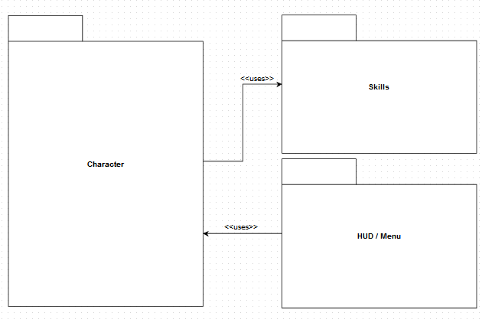

## *Figure 1: Package Diagram - Overview*

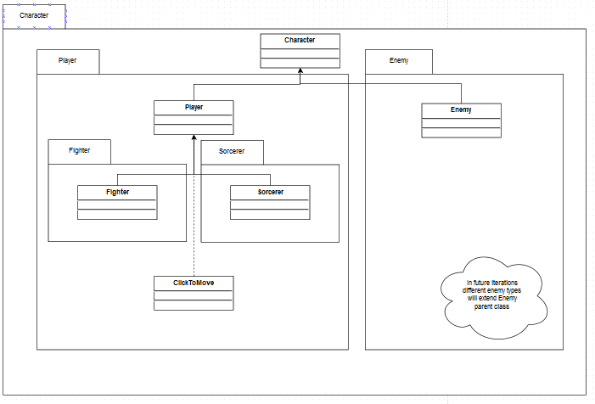

## *Figure 2: Package Diagram - Character*

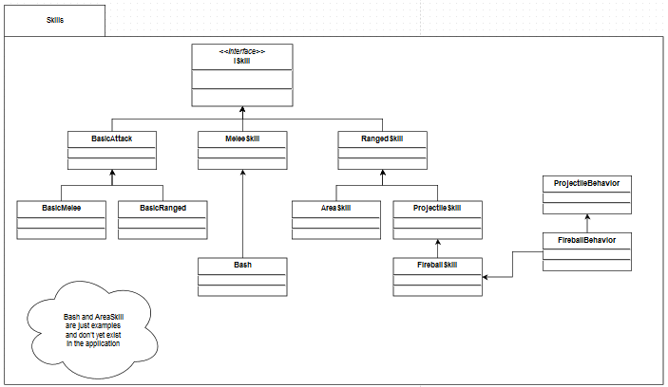

## *Figure 2: Package Diagram - Skills*

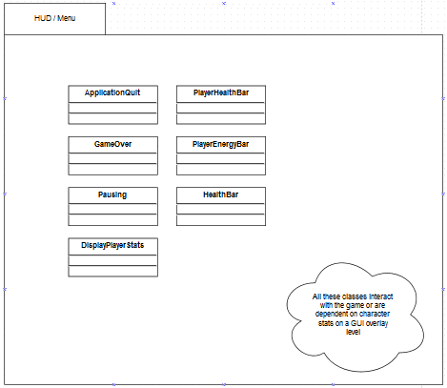

## *Figure 4: Package Diagram – HUD/Menu*

Class Diagram: To get detailed Architecture information of the system, check the HTML documentation at the following Address “\Second-Soul\Second Soul\Docs\”.

# Architectural requirements: goals and constraints

## Functional Requirements

|  |  |  |
| --- | --- | --- |
| **ID** | **User Stories** | **Points** |
| US 1.0 | As a user, i want to be able play with either the Fighter Soul or the Sorcerer Soul | 1 |
| US 1.0.1 | As a Fighter, i want to move my character | 8 |
| US 1.0.2 | As a Sorcerer , i want to control the location of the spells cast | 3 |
| US 1.1 | As a user, i want to keep track of the user’s accomplishments | 2 |
| US 1.1.1 | As a user, i want to be able to save my data | 8 |
| US 1.1.2 | As a user, i want to be able to load my data | 3 |
| US 1.2 | As a user, i want to be able improve my character’s stats according to my preferences and character class | 13 |
| US 1.2.1 | As a Fighter, i want to be able to choose the character’s class | 1 |
| US 1.2.2 | As a Sorcerer, i want to be able to choose the character’s class | 1 |
| US 1.3 | As a user, i want to be able to set the AI to control the Sorcerer Soul in a single player environment | 8 |
| US 1.4 | As a user, i want to be able to fight Monsters | 5 |
| US 1.4.0.1 | As a user, I want monsters to spawn | 3 |
| US 1.4.1 | As a user, i want to be able to kill Monsters | 2 |
| US 1.4.2 | As a user, i want Monsters to have different behavior depending on their type | 20 |
| US1.4.3.1 | As a user, I want the monsters to notice me at a set distance | 5 |
| US 1.4.3.2 | As a user, I want monsters to be able to find an appropriate path to me | 13 |
| US 1.5.2(EPIC) | As a user, i want to play simultaneously with friend, with each one on a different platform (computer) | EPIC |
| US 1.5.2.1 | As a user I want to be able to join another player’s session | 5 |
| US 1.5.2.2 | As a user, I want to be able to spectate another player’s game | 13 |
| US 1.5.2.3 | As a user, I want to be able to participate in another player’s game | 13 |
| US 1.6 | As a user, i want to manipulate the inventory | 5 |
| US 1.6.1 | As a user, i want to be able to find a treasure chest and add it contents to my inventory | 5 |
| US 1.6.2 | As a Fighter, i want to be able to equip weapons | 3 |
| US 1.6.3 | As a Fighter, i want to be able to equip armors | 3 |
| US 1.6.4 | As a Fighter , i want to be able to equip accessories | 3 |
| US 1.6.5 | As a user, i want to be able to heal my character with a healing potion | 2 |
| US 1.6.6 | As a user, i want to be able to recharge the energy of my character | 2 |
| ~~US 1.6.7~~ | ~~As a user, i want to be able to use items to kill monsters~~ | -- |
| ~~US 1.7~~ | ~~As a user, i want to be able to change camera location~~ | ~~--~~ |
| US 1.8 | As a user, i want to see detailed stats about my character in a view | 2 |
| US 1.8.1 | As a user, i want to see my character’s health bar on the HUD | 1 |
| US 1.8.2 | As a user, i want to see my character’s energy bar on the HUD | 1 |
| US 1.9 | As a user, i want to be able to access a pause menu | 1 |
| ~~US 1.9.1~~ | ~~As a user, i want to be able to view my equipment list from the menu~~ | -- |
| US 1.9.2 | As a user, i want to be able to view my inventory list | 2 |
| US 1.9.3.1 | As a user, I want to be able to explore a map | 13 |
| US 1.9.3.2 | As a user, i want to be able to view a mini-map on the HUD | 8 |
| ~~US 1.9.4~~ | ~~As a user, i want to be able to access the save menu~~ | -- |
| US 1.9.5 | As a user, i want to be able to access a help menu (view) | 1 |
| US 1.9.6 | As a Fighter, i want to be able to invite a player (friends) to your session | 8 |
| US 1.9.7 | As a Fighter, i want to be able to remove a player | 2 |
| US 2.0 | As a Sorcerer, i want to be able to use spells | ? |
| US 2.0.1 | As a Sorcerer, i want to choose list of spells in a “ring” menu | ? |
| ~~US 2.0.2~~ | ~~As a user controlling the Sorcerer Soul, I want to remove a spell from the quick access list of spells~~ | -- |
| US 2.1 | As a user, i want to be able to play multiplayer | 13 |
| US 2.2 | As a user, i want to be able to see the enemy data, such as his health bar and his name | 3 |
| US 2.3 | As a user, i want to be able to chat with others during multiplayer | 8? |
| US.1.4.3 | As a user, i want to be able to see a game over screen when my character dies | 2 |
| US.1.4.4 | As a user, I want to be able to respawn | 3 |

## Non-Functional Requirements

|  |  |
| --- | --- |
| ID | User Stories |
| NFR 1.0 | As a user, i want the game to run in a fast manner |
| NFR 1.1 | As a user, i want the game to be easily playable to users |
| NFR 1.2 | As a user, i want the game to run in real time when playing with people |
| NFR 1.3 | As a user, i want the quick access bar to be easily and fastly used |
| NFR 1.4 | As a user, i want to receive the messages send to me an in fast manner |
| NFR 1.5 | As a user, i want to receive feedback when an item has been added to the inventory |

# Scenarios

The scenarios (or functional view) represent the behavior of the system as seen by its actors. Use case scenarios describe sequences of interactions between actors and the system (seen as a black box) as well as between the system and external systems. The *UML use case diagram* is used to capture this view. It is important to note that the easiest way to extract the architecture is to closely relate the requirements and their respective scenarios. This helps to better understand the system, conceptualize it lead to further analysis. To further simplify this process, we will show below all the system’s use-cases and extract from it the Use case diagram.

## Use case

In this section, we find the use cases related to the system we wish to build. Trivial Behavior such as Saving and Loading are not included in the use cases below. A use case with Base Use Case in its title means that the use case is divided into multiple smaller use cases. Each use case relates to 1 or more user stories, which are specified in the related user Story section.

|  |
| --- |
| **Use Case 1.0: Explore Dungeon (Base Use-Case)** |
| **ID: UC-1.0** |
| **Description:**   * **User controls the character, and moves him around to find treasures, and complete mission inside dungeons. He has to fend off monster that may attack him during his exploration of the location. He uses the item and equipment he has in his inventory to fight the monsters and he collects item and/or equipment that they drop after they are defeat.** |
| **Related User Stories:**   * **US - 1.0: Playing with Fighter Soul or Sorcerer Soul.** * **US - 1.0.1: Moving the Fighter Soul.** * **US - 1.0.2: Locating spells as the Sorcerer Soul.** * **US - 1.3: Setting AI as Sorcerer Soul.** * **US - 1.4: Fighting Monsters.** * **US - 1.4.1: Killing Monsters.** * **US - 1.4.2: Dying From Monsters.** * **US - 1.5: Playing With a Friend.** * **US - 1.5.1: Playing Concurrently with a Friend.** * **US - 1.5.2: Playing with a Friend on a different platform.** * **US - 1.6: Access to inventory.** * **US - 1.6.1: Collect Items and add them to inventory.** * **US - 1.6.2: Equip Weapon.** * **US - 1.6.3: Equip Armor.** * **US - 1.6.4: Equip Accessories.** * **US - 1.6.5: Use item to heal Character.** * **US - 1.6.6: Use item to recharge energy.** * **US - 1.6.7: Use items to kill monsters.** * **US - 1.8: Display Key Stats.** * **US - 1.8.1: Display Health Bar.** * **US - 1.8.2: Display Energy Bar.** * **US - 1.9: Access Menu.** * **US - 1.9.1: Access Equipment List.** * **US - 1.9.2: Access Inventory.** * **US - 1.9.6: Add Player as Sorcerer Soul.** * **US - 1.9.7: Remove Player as Sorcerer Soul.** * **US - 2.0: Quick Access to spell list.** * **US - 2.0.1: Make Quick Access list (by adding spells).** * **US - 2.0.2: Remove Spell from quick Access list.** * **US - 2.1: Multiplayer.** * **US - 2.2: Display Enemy key Stats.** * **US - 2.3: Chat with other players.** |
| **Level:**   * **User-Goal.** |
| **Primary Actor:**   * **1st Player – Fighter Soul.** |
| **Secondary Actor:**   * **2nd Player – Sorcerer Soul.** * **AI – Sorcerer Soul.** * **Multiplayer (More than 2 players).** |
| **Stakeholder and interest:**   * **1st Player – Is interested in having to explore the dungeon, find treasure and complete the mission. He also likes to kill these monsters and hopes they might drop rare items.** * **2nd Player – Is interested in helping the first player by casting spells to increase the 1st player’s stats, health, Energy or simply kill other monsters.** |
| **Pre-Condition:**   * **Fighter Soul has equipment on** * **Sorcerer Soul has equipment on.** * **2nd player or AI activated for Sorcerer Soul.** * **Multiplayer enabled/disabled.** |
| **Post-Condition:**   * **Player(s) can explore dungeon.** * **Player(s) can fight monsters.** * **Player(s) can collect items from monsters and treasure chest.** * **Player(s) can complete mission.** * **If more than 1 player then Players can Chat together.** |
| **Main Scenario (Success):**   1. **Fighter Soul (controlled by 1st Player) moves in the dungeon.** 2. **Fighter Soul encounters monsters and initiates battle.** 3. **Fighter Soul and Sorcerer Soul (AI) use their arsenal (skills and spells) to kill monsters.** 4. **After defeating the monsters, the Fighter Soul can collect items dropped by their opponents.** 5. **Fighter Soul finds a treasure chest and collects it.** 6. **Fighter Soul Completes the Mission (either by killing a monster or finding a treasure).** |
| **Alternative Flows:**  **Flow A: Sorcerer Soul controlled by a another Player**   1. **Sorcerer Soul Controlled by 2nd Player.** 2. **Both Players can communicate through the chat system throughout all the steps.**   **Flow B: Multiplayer**   1. **Fighter Soul alongside other players controlling their own Fighter soul.** 2. **Proceed with step 2 to 6 with all Players, note that the mission is complete is 1 Fighter Soul completes the mission, and all items are unique (only pick-able by one Fighter Soul).** |
| **Special Requirements:**   * **Internet Connectivity for more than 1 player.** |

|  |
| --- |
| **Use Case 1.0.1: Battle** |
| **ID: UC-1.0.1** |
| **Description:**   * **User controls the character, and moves him to fight more efficiently. He damages them by using physical attacks with the Fighter Soul and Magical Attack with the Sorcerer Soul.** |
| **Related User Stories:**   * **US - 1.0: Playing with Fighter Soul or Sorcerer Soul.** * **US - 1.0.1: Moving the Fighter Soul.** * **US - 1.0.2: Locating spells as the Sorcerer Soul.** * **US - 1.3: Setting AI as Sorcerer Soul.** * **US - 1.4: Fighting Monsters.** * **US - 1.4.1: Killing Monsters.** * **US - 1.4.2: Dying From Monsters.** * **US - 1.5: Playing With a Friend.** * **US - 1.5.1: Playing Concurrently with a Friend.** * **US - 1.5.2: Playing with a Friend on a different platform.** * **US - 1.6: Access to inventory.** * **US - 1.6.1: Collect Items and add them to inventory.** * **US - 1.6.2: Equip Weapon.** * **US - 1.6.3: Equip Armor.** * **US - 1.6.4: Equip Accessories.** * **US - 1.6.5: Use item to heal Character.** * **US - 1.6.6: Use item to recharge energy.** * **US - 1.6.7: Use items to kill monsters.** * **US - 1.8: Display Key Stats.** * **US - 1.8.1: Display Health Bar.** * **US - 1.8.2: Display Energy Bar.** * **US - 1.9: Access Menu.** * **US - 1.9.1: Access Equipment List.** * **US - 1.9.2: Access Inventory.** * **US - 1.9.6: Add Player as Sorcerer Soul.** * **US - 1.9.7: Remove Player as Sorcerer Soul.** * **US - 2.0: Quick Access to spell list.** * **US - 2.0.1: Make Quick Access list (by adding spells).** * **US - 2.0.2: Remove Spell from quick Access list.** * **US - 2.1: Multiplayer.** * **US - 2.2: Display Enemy key Stats.** * **US - 2.3: Chat with other players.** |
| **Level:**   * **User-Goal.** |
| **Primary Actor:**   * **1st Player – Fighter Soul.** |
| **Secondary Actor:**   * **2nd Player – Sorcerer Soul.** * **AI – Sorcerer Soul.** * **Multiplayer (More than 2 players).** |
| **Stakeholder and interest:**   * **1st Player – Is interested in battling monsters and collecting items dropped by them** * **2nd Player – Is interested in helping the first player by casting spells to increase the 1st player’s stats, health, Energy or simply kill other monsters.** |
| **Pre-Condition:**   * **Fighter Soul has equipment on** * **Sorcerer Soul has equipment on.** * **2nd player or AI activated for Sorcerer Soul.** * **Multiplayer enabled/disabled.** |
| **Post-Condition:**   * **Player(s) can fight monsters.** * **Player(s) can collect items from monsters.** * **Player(s) can complete mission.** * **If more than 1 player then Players can Chat together.** |
| **Main Scenario (Success):**   1. **Fighter Soul (controlled by 1st Player) locates monsters.** 2. **Players see Health bar, Energy bar and their Key stats on-screen** 3. **Players see Monsters Key stats on-screen** 4. **Fighter Soul uses physical attacks (regular or skills) whereas the Sorcerer soul uses Energy to cast spells to damage monsters or heal the Fighter Soul.** 5. **Fighter Soul and Sorcerer soul use items to cause damage to monsters.** 6. **Character receives damage from monsters’ attacks.** 7. **Repeat Step 4, 5 or 6 until monsters are dead.** 8. **Collect item dropped by defeated monsters.** |
| **Alternative Flows:**  **Flow A: Character dies.**   1. **Character dies from monsters’ attack** 2. **Game over screen is displayed to Player(s)**   **Flow B: Multiplayer.**   1. **All Fighter Souls uses physical attacks while all the sorcerer souls attack monsters.** |
| **Special Requirements:**   * **Internet Connectivity for more than 1 player.** |

|  |
| --- |
| **Use Case 1.0.2: Collecting Treasure** |
| **ID: UC-1.0.2** |
| **Description:**   * **User controls the character, and moves him to treasure location, and collect said treasure.** |
| **Related User Stories:**   * **US - 1.0: Playing with Fighter Soul or Sorcerer Soul.** * **US - 1.0.1: Moving the Fighter Soul.** * **US - 1.6: Access to inventory.** * **US - 1.6.1: Collect Items and add them to inventory.** * **US - 2.1: Multiplayer.** * **US - 2.3: Chat with other players.** |
| **Level:**   * **User-Goal.** |
| **Primary Actor:**   * **1st Player – Fighter Soul.** |
| **Secondary Actor:**   * **Multiplayer (More than 2 players) controlling two or more Fighter Souls** |
| **Stakeholder and interest:**   * **1st Player – Is interested in collecting items from treasure chests** |
| **Pre-Condition:**   * **Fighter Soul has equipment on** * **Sorcerer Soul has equipment on.** * **2nd player or AI activated for Sorcerer Soul.** * **Multiplayer enabled/disabled.** |
| **Post-Condition:**   * **Player(s) can collect items from treasure chests.** * **Player(s) can complete mission.** * **If more than 1 player then Players can Chat together.** |
| **Main Scenario (Success):**   1. **Fighter Soul (controlled by 1st Player) locates a treasure chests.** 2. **Fighter Soul opens treasure chest and item is added to the inventory.** |
| **Alternative Flows:**  **Flow A: Inventory is Full**   1. **Fighter Soul cannot claim item and treasure chests closes again.** |
| **Special Requirements:**   * **Internet Connectivity for more than 1 player.** |

|  |
| --- |
| **Use Case 1.0.3: Heal Health Points** |
| **ID: UC-1.0.3** |
| **Description:**   * **User can restore the character’s Health using the appropriate healing potion.** |
| **Related User Stories:**   * **US - 1.0: Playing with Fighter Soul or Sorcerer Soul.** * **US - 1.0.1: Moving the Fighter Soul.** * **US - 1.6: Access to inventory.** * **US - 1.6.1: Collect Items and add them to inventory.** * **US - 1.6.5: Heal Character** * **US - 1.8.1: Display Health Bar** |
| **Level:**   * **User-Goal.** |
| **Primary Actor:**   * **1st Player – Fighter Soul.** * **2nd player or AI** |
| **Secondary Actor:**   * **Multiplayer (More than 2 players) controlling two or more Fighter Souls** |
| **Stakeholder and interest:**   * **Player (1st,2nd or AI ) – Is interested in healing to prevent game-over.** |
| **Pre-Condition:**   * **Fighter Soul has equipment on** * **Sorcerer Soul has equipment on.** * **2nd player or AI activated for Sorcerer Soul.** * **Multiplayer enabled/disabled.** * **Player inventory contains at least 1 healing potion** |
| **Post-Condition:**   * **Character is healed.** |
| **Main Scenario (Success):**   1. **Player (either Fighter Soul or Sorcerer Soul) opens inventory.** 2. **Player uses the healing items of his choice.** 3. **Player sees his Health Bar has increased.** |
| **Alternative Flows:**  **Flow A: No healing item available in inventory.**   1. **Player doesn’t have any healing items and closes the inventory.** |
| **Special Requirements:**   * **Internet Connectivity for more than 1 player.** |

|  |
| --- |
| **Use Case 1.0.4: Restore Energy Points** |
| **ID: UC-1.0.4** |
| **Description:**   * **User can restore the character’s Energy using the appropriate energy restoring potions.** |
| **Related User Stories:**   * **US - 1.0: Playing with Fighter Soul or Sorcerer Soul.** * **US - 1.0.1: Moving the Fighter Soul.** * **US - 1.6: Access to inventory.** * **US - 1.6.1: Collect Items and add them to inventory.** * **US - 1.6.6: Restore Energy to Character** * **US - 1.8.2: Display Energy Bar** |
| **Level:**   * **User-Goal.** |
| **Primary Actor:**   * **1st Player – Fighter Soul.** * **2nd player or AI** |
| **Secondary Actor:**   * **Multiplayer (More than 2 players) controlling two or more Fighter Souls** |
| **Stakeholder and interest:**   * **Player (1st,2nd or AI ) – Is interested in healing to prevent game-over.** |
| **Pre-Condition:**   * **Fighter Soul has equipment on** * **Sorcerer Soul has equipment on.** * **2nd player or AI activated for Sorcerer Soul.** * **Multiplayer enabled/disabled.** * **Player inventory contains at least 1 energy restoring potion** |
| **Post-Condition:**   * **Character’s energy is restored.** |
| **Main Scenario (Success):**   1. **Player (either Fighter Soul or Sorcerer Soul) opens inventory.** 2. **Player uses the Energy restoring items of his choice.** 3. **Player sees his Energy Bar has increased.** |
| **Alternative Flows:**  **Flow A: No healing item available in inventory.**   1. **Player doesn’t have any energy restoring items and closes the inventory.** |
| **Special Requirements:**   * **Internet Connectivity for more than 1 player.** |

|  |
| --- |
| **Use Case 1.0.5: Access Map** |
| **ID: UC-1.0.5** |
| **Description:**   * **User can determine his own location, or any location in the vicinity.** |
| **Related User Stories:**   * **US - 1.0: Playing with Fighter Soul or Sorcerer Soul.** * **US - 1.0.1: Moving the Fighter Soul.** * **US - 1.9: Access Menu.** * **US - 1.9.3: Access Map** |
| **Level:**   * **User-Goal.** |
| **Primary Actor:**   * **1st Player – Fighter Soul.** * **2nd player or AI** |
| **Secondary Actor:**   * **Multiplayer (More than 2 players) controlling two or more Fighter Souls** |
| **Stakeholder and interest:**   * **Player (1st,2nd or AI ) – Is interested in determining a certain location.** |
| **Pre-Condition:**   * **Fighter Soul has equipment on** * **Sorcerer Soul has equipment on.** * **2nd player or AI activated for Sorcerer Soul.** * **Multiplayer enabled/disabled.** * **Player has the appropriate Map** |
| **Post-Condition:**   * **Player has the Map opened** |
| **Main Scenario (Success):**   1. **Player (either Fighter Soul or Sorcerer Soul) opens menu.** 2. **Player opens the Map section.** 3. **Player sees a Map of the area.** |
| **Alternative Flows:**  **Flow A: No Map available.**   1. **Player cannot open the Map tab, since he doesn’t have it.** |
| **Special Requirements:**   * **Internet Connectivity for more than 1 player.** |

|  |
| --- |
| **Use Case 1.0.6: Adding Player (as Sorcerer Soul)** |
| **ID: UC-1.0.6** |
| **Description:**   * **User can add a player as a Sorcerer Soul.** |
| **Related User Stories:**   * **US - 1.0: Playing with Fighter Soul or Sorcerer Soul.** * **US - 1.0.1: Moving the Fighter Soul.** * **US - 1.9: Access Menu.** * **US - 1.9.6: Add Player.** |
| **Level:**   * **User-Goal.** |
| **Primary Actor:**   * **1st Player – Fighter Soul.** |
| **Secondary Actor:**   * **Multiplayer (More than 2 players) controlling two or more Fighter Souls** |
| **Stakeholder and interest:**   * **Player (1st,2nd or AI ) – Is interested in adding a companion.** |
| **Pre-Condition:**   * **Fighter Soul has equipment on** * **Sorcerer Soul has equipment on.** * **Multiplayer enabled/disabled.** |
| **Post-Condition:**   * **Player has the added the player** |
| **Main Scenario (Success):**   1. **Fighter Soul opens menu.** 2. **Player opens the Add player section.** 3. **Player is able to play with added player.** |
| **Alternative Flows:**  **Flow A: No Player available.**   1. **Player cannot add player, since he isn’t detected.** |
| **Special Requirements:**   * **Internet Connectivity for more than 1 player.** |

|  |
| --- |
| **Use Case 1.0.7: Remove Player (as Sorcerer Soul)** |
| **ID: UC-1.0.7** |
| **Description:**   * **User can remove a player as a Sorcerer Soul.** |
| **Related User Stories:**   * **US - 1.0: Playing with Fighter Soul or Sorcerer Soul.** * **US - 1.0.1: Moving the Fighter Soul.** * **US - 1.9: Access Menu.** * **US - 1.9.7: Add Player.** |
| **Level:**   * **User-Goal.** |
| **Primary Actor:**   * **1st Player – Fighter Soul.** |
| **Secondary Actor:**   * **Multiplayer (More than 2 players) controlling two or more Fighter Souls** |
| **Stakeholder and interest:**   * **Player (1st,2nd or AI ) – Is interested in removing a companion.** |
| **Pre-Condition:**   * **Fighter Soul has equipment on** * **Sorcerer Soul has equipment on.** * **Multiplayer enabled/disabled.** |
| **Post-Condition:**   * **Player has the remove the player.** |
| **Main Scenario (Success):**   1. **Fighter Soul opens menu.** 2. **Player opens the remove player section.** 3. **Player is able to play without the other player.** |
| **Alternative Flows:**   * **None** |
| **Special Requirements:**   * **Internet Connectivity for more than 1 player.** |

|  |
| --- |
| **Use Case 1.0.8: Enabling Multiplayer** |
| **ID: UC-1.0.8** |
| **Description:**   * **User can add other player to help him complete a Mission.** |
| **Related User Stories:**   * **US - 1.0: Playing with Fighter Soul or Sorcerer Soul.** * **US - 1.0.1: Moving the Fighter Soul.** * **US - 1.9: Access Menu.** * **US - 1.9.6: Add Player.** * **US - 2.1: Enable Multiplayer.** |
| **Level:**   * **User-Goal.** |
| **Primary Actor:**   * **1st Player – Fighter Soul.** |
| **Secondary Actor:**   * **Multiplayer (More than 2 players) controlling two or more Fighter Souls** |
| **Stakeholder and interest:**   * **Player (1st,2nd or AI ) – Is interested in playing with friends** |
| **Pre-Condition:**   * **Fighter Soul has equipment on** * **Sorcerer Soul has equipment on.** * **Before start of a Mission.** |
| **Post-Condition:**   * **Player is playing with friends.** |
| **Main Scenario (Success):**   1. **Fighter Soul opens menu.** 2. **Enables Multiplayer.** 3. **He is able to play with Friends.** |
| **Alternative Flows:**  **Flow A: No Player available.**   1. **Player cannot add player, since he isn’t detected.** |
| **Special Requirements:**   * **Internet Connectivity for more than 1 player.** |

|  |
| --- |
| **Use Case 1.0.9: Chatting with Another Player** |
| **ID: UC-1.0.9** |
| **Description:**   * **User can chat with another player during a Mission.** |
| **Related User Stories:**   * **US - 1.0: Playing with Fighter Soul or Sorcerer Soul.** * **US - 1.0.1: Moving the Fighter Soul.** * **US - 1.9: Access Menu.** * **US - 2.1: Enable Multiplayer.** * **US - 2.3: Chat** |
| **Level:**   * **User-Goal.** |
| **Primary Actor:**   * **1st Player – Fighter Soul.** * **Multiplayer (More than 2 players) controlling two or more Fighter Souls** |
| **Secondary Actor:**   * **N/A** |
| **Stakeholder and interest:**   * **Player (1st,2nd or AI ) – Is interested in Chatting with friends** |
| **Pre-Condition:**   * **Fighter Soul has equipment on** * **Sorcerer Soul has equipment on.** * **Multiplayer Enabling.** |
| **Post-Condition:**   * **Player is Chatting with friends.** |
| **Main Scenario (Success):**   1. **Fighter Soul opens Chat menu.** 2. **Fighter Soul Sends Message to his Friend.** 3. **Fighter Soul receives Notification that his message was added to the logs.** 4. **Fighter Soul receives Messages from his friends.** |
| **Alternative Flows:**  **Flow A: N/A.** |
| **Special Requirements:**   * **Internet Connectivity for more than 1 player.** |

## Use case diagram

In this section, we provide an overview of the system. Notice 3 Main Components: Explore Dungeon, Access Inventory and Keep track of Accomplishments. The Explore Dungeon component contains several important parts including Fighting Monsters and Collecting Treasure. We also have 3 components requiring Internet Connection: Add Sorcerer Soul, Enable Multiplayer and Chatting. Here below is the Use Case Diagram:

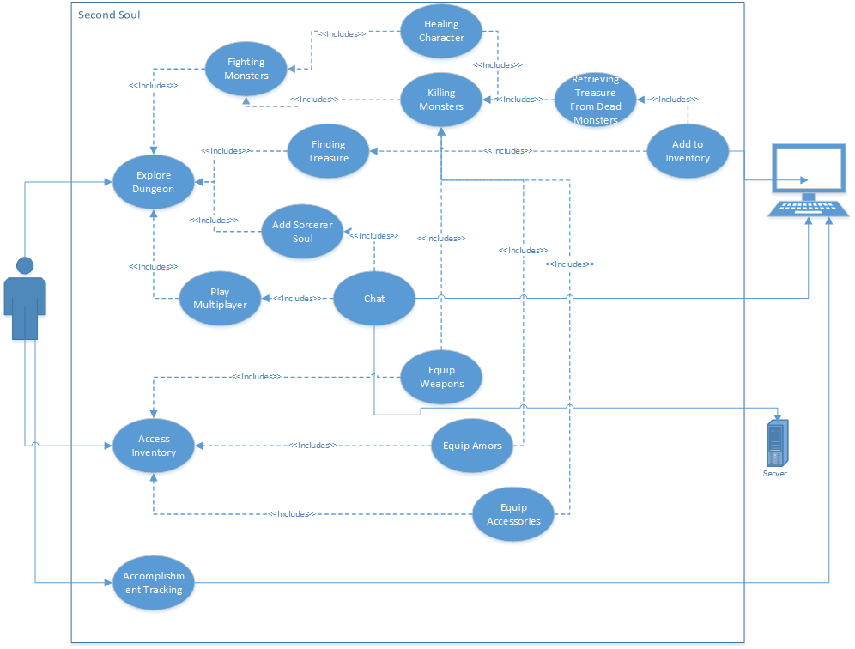

## *Figure 5: Use Case Diagram*